## Reports/Inventory Reports/CII Reports/CII Drug Summary:

Request:

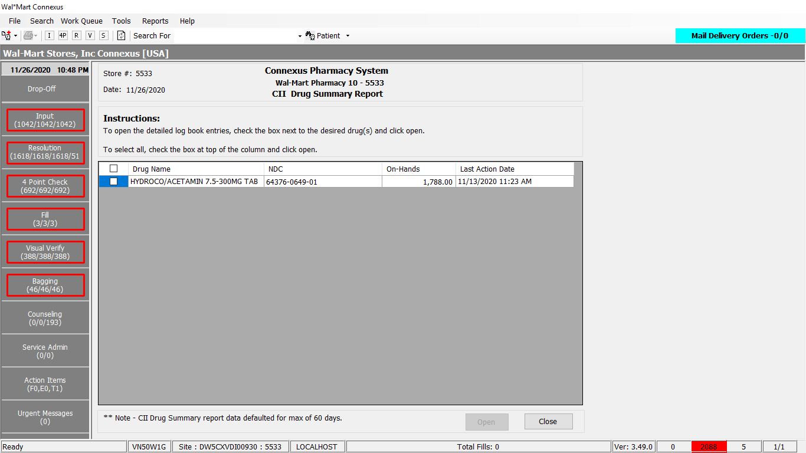

Response:

Getting white page(need to analyze)

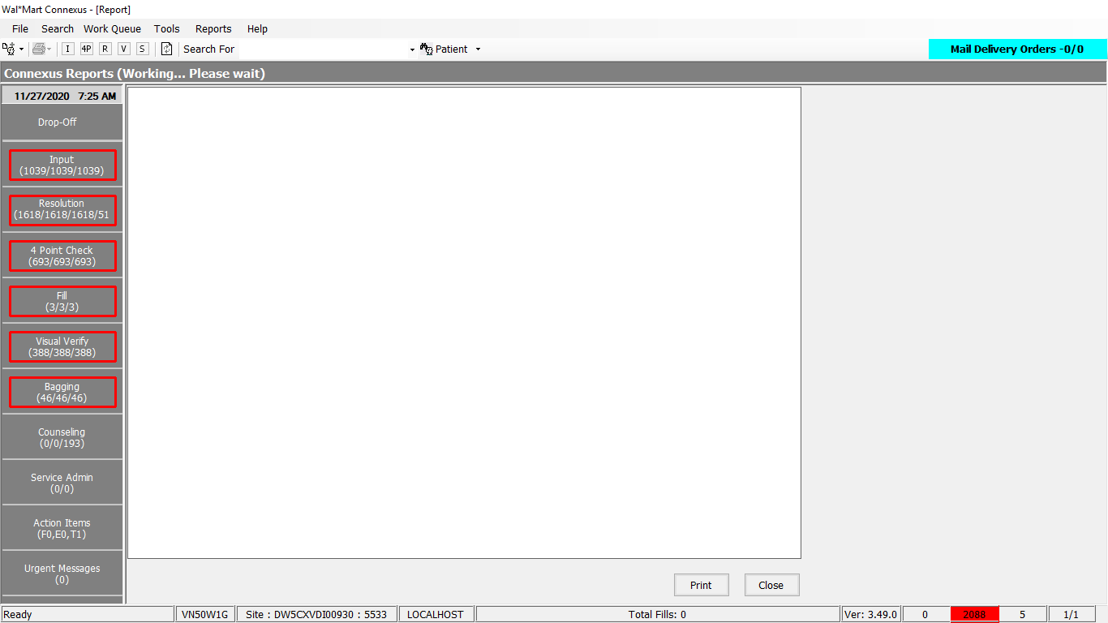

Query:

Public Const CIIDrugSummary As String = " SELECT tmp.mds_fam_id, tmp.ndc_nbr, tmp.short_name, tmp.on_hand_qty, " &

" NVL(piia1.adjmt_ts, tmp.on_hand_chg_ts) As time_stamp, " &

" (SELECT pct.code_desc " &

" FROM rx21c:pharmacy_code_txt pct " &

" WHERE pct.code_id = piia1.adjmt_type_code) As desc, " &

" tmp.on_hand_qty * pic1.phm_item_cost_amt AS cost " &

" FROM (SELECT DISTINCT(pi.mds_fam_id) as mds_fam_id, " &

" pi.ndc_nbr, " &

" pp.short_name, " &

" pi.on_hand_qty, " &

" pi.on_hand_chg_ts " &

" FROM (pharmacy_item pi JOIN phm_item_inv_adjmt piia ON piia.mds_fam_id = pi.mds_fam_id) " &

" JOIN pharmacy_product pp ON pp.product_mds_fam_id = pi.product_mds_fam_id " &

" WHERE pp.drug_control_code = 2300 " &

" AND (pi.on_hand_qty > 0 " &

" AND piia.adjmt_ts >= TODAY - 60 UNITS DAY AND pi.on_hand_chg_ts >= TODAY - 60 UNITS DAY) " &

" ) tmp " &

" LEFT OUTER JOIN phm_item_inv_adjmt_log piia1 ON piia1.mds_fam_id = tmp.mds_fam_id " &

" AND (piia1.adjmt_ts >= TODAY - 60 UNITS DAY) AND piia1.log_id =(SELECT MAX(log_id) " &

" FROM phm_item_inv_adjmt_log piia2 " &

" WHERE piia1.mds_fam_id = piia2.mds_fam_id) " &

" LEFT OUTER JOIN phm_item_cost pic1 ON tmp.mds_fam_id = pic1.mds_fam_id " &

" AND pic1.cost_type_code = 3001 " &

" AND pic1.effective_date =(SELECT MAX( effective_date ) " &

" FROM phm_item_cost pic2 " &

" WHERE pic1.mds_fam_id = pic2.mds_fam_id " &

" AND pic2.cost_type_code = 3001) "

DAL:

Public Function GetCIIDrugSummary(ByVal siteId As Integer, ByVal c2DrugSummaryReportDays As Integer) _

As List(Of ReturnToStockInfoBE) Implements IItemDAL.GetCIIDrugSummary

Using (New Tracer(ConnexusCommonConstants.ConnexusTracer))

Dim cIIDrugSummaryInfoList As New List(Of ReturnToStockInfoBE)

Dim paramList As New List(Of DbParameter)

paramList.AddParameter(DbType.Int32, c2DrugSummaryReportDays)

Dim local As New LocalizationManager

Using dr As IDataReader = ExecuteReader(DatabaseEnum.Pharmacy_Offering, siteId, ItemQueries.CIIDrugSummary, paramList)

'Retrieve data from datareader to data entity

While dr.Read

Dim CIIDrugSummaryInfo As New ReturnToStockInfoBE

With CIIDrugSummaryInfo

.NDC = String.Format(local, "{0:N}", dr.GetValueOrDefault(Of String)("ndc_nbr").SafeTrim)

.Description = dr.GetValueOrDefault(Of String)("short_name").SafeTrim

.UnitCost = dr.GetValueOrDefault(Of Decimal)("cost")

'Assigning the on_hand_qty to vial quantity

.VialQuantity = (dr.GetValueOrDefault(Of Decimal)("on_hand_qty"))

.LastChangets = dr.GetValueOrDefault(Of DateTime)("time_stamp")

.Status = dr.GetValueOrDefault(Of String)("desc").SafeTrim

.MdsfamId = dr.GetValueOrDefault(Of Integer)("mds_fam_id")

End With

cIIDrugSummaryInfoList.Add(CIIDrugSummaryInfo)

End While

Return cIIDrugSummaryInfoList

End Using

End Using

End Function